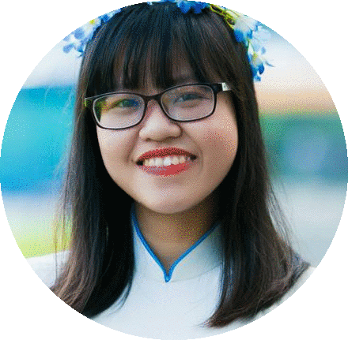**PHAM CAO HONG HANH**

*LAB TECHNICIAN*

“*Experience about researching, analysising method, process improvement, skill in lab, constantly learning and developing ability will be chances so that I can work as lab technician.*”



# EDUCATION

**BACH KHOA UNIVERSITY AUG 2013 – JAN 2018**



29/05/1995

0165 314 1749

[phamcaohonghanh95@gmail.com](mailto:phamcaohonghanh95@gmail.com)

[www.facebook.com/pham.hanh.12720](http://www.facebook.com/pham.hanh.12720) District 11, Ho Chi Minh, Viet Nam

Major: Chemical Engineering – Organic Chemistry

GPA: 7.7/10

**SCIENCE RESEARCH JAN 2016 – JAN 2017**

Field: Personal care product

Title: Research on biological activities of *Cleistocalyx operculatus* extract and application to personal care product.



# WORK EXPERIENCE

**LABORATORY AT BKU JAN 2017 – JAN 2018**

**Thesis**

**OBJECTIVE**

To work in a dynamic professional environment with growing organization and utilize my creativity and innovative thinking for benefit of the organization and myself.

**SKILL**

* Data analysis
* Make a plan
* Teamwork
* Work under high pressure
* Work management
* Testing method: UV-VIS, Antioxidant, Antimicrobial,…

**REFERENCES**

Assoc. Prof. PhD Le Thi Hong Nhan

Workplace: Organic Chemical Engineering Deparment - BKU

Email: [lthnhan@hcmut.edu.vn](mailto:lthnhan@hcmut.edu.vn)

Mobile: 093 305 6664

**INTERESTS**

* Research on basic personal care and home care product.
* Find the necessary information, articles, theory about related topic.
* Find out the method and technical parameter to conduct the topic: the extraction procedure, cosmetic formulas, conducted process, evaluation methods, ...
* Conduct on the active element and personal care samples.
* Use the related equipments in lab to evaluate the sample properties.
* Recommend the information of new product.

**TVR CORPORATION JUNE 2017 – JULY 2017**

**Internship**

* Learn some cosmetic formulations, testing method.
* Experience in actual production process: production standards, QC.
* Research and develop some cosmetic formulations.



# ACTIVITIES

**TIEP SUC MUA THI 2015 – 2016**

**Team leader**

* Make a plan about program organization.
* Organize the event during the program: recruitment, opening,..
* Manage finance and human resources.
* Solve the urgent problems & share work to other members.

**VOLUNTARY SUMMER CAMPAIGN 2014**

* Support for the local children: education, entertainment,...
* Support to organize some activities.